**Customer Retention Case Study Report**







**Prepared by Suneel Kumar**

Data Science Intern at Flip Robo Technologies

|  |
| --- |
| **INTRODUCTION** |
|  |
| **Problem Statement:**  Customer satisfaction has emerged as one of the most important factors that guarantee the success of online store; it has been posited as a key stimulant of purchase or repurchase intentions and customer loyalty.  A comprehensive review of the literature, theories and models have been carried out to propose the models for customer activation and customer retention.  Five major factors that contributed to the success of an e-commerce store have been identified as: **Service quality, System quality, Information quality, Trust and Net benefit**.  The research furthermore investigated the factors that influence the online customers repeat purchase intention.  The combination of both utilitarian value and hedonistic values are needed to affect the repeat purchase intention (loyalty) positively.  The data is collected from the Indian online shoppers.  Results indicate the e-retail success factors, which are very much critical for customer satisfaction. |

|  |
| --- |
| **Use Case Diagram** |
|  |

In the use case diagram above, you can see that the intent of repeated purchases is basically based on a customer retention strategy based on pleasure value and utilitarian value. We also find that the perceived risks affect your purchase and repurchase intent. Pleasure value is made up of five key components: satisfaction, role, best offer, social aspects, and adventurous standards. In terms of utility value, we have product offerings, convenience, product information, and money savings.

|  |
| --- |
| **Benefits of Customer Retention:**   1. Retention is cheaper than acquisition    * While the old adage about "it costs five times as much to   acquire a new customer" may not be accurate  in every case, the basic principle is spot on: it’s  more cost-effective to keep someone in the fold than to bring in new customers.   * + Even still, if it’s data you want, there has been plenty of research into acquisition vs retention, and every one of them has come back with the economics favoring retention as the more economically viable focus.   + One caveat though: retention is cheaper than acquisition, but it   isn’t necessarily easier.   1. Loyal customers are more profitable    * Not only is loyalty cheaper, it has better returns. According to research, engaged consumers buy 90% more frequently, spend 60% more per transaction and are five times more likely to indicate it is the only brand they would purchase in the future.    * On average, they’re delivering 23% more revenue and profitability over the average customer.    * While loyal customers are more profitable, don’t take their   loyalty for granted. |

* They’ll be more open to price increases, but be cautious not to

raise prices simply to see how long they’ll stick around.

* Consider the flipside: “Actively disengaged” customers (people who oppose the brand and may be actively spreading that opinion) can cost a brand 13% of its revenue.

1. Your brand will stand out from the crowd
   * Put your consumer hat on, and consider how many brands you interact with that actually seem to value your patronage.
   * You can probably only think of one or two.
   * Most brands focus on acquisition, which makes the retention- centric among us stand out even more.
   * People see around 10,000 marketing exposures a day, but only engage with a few of them.
   * The ones that earn continual engagement are those with whom they feel an emotional connection with on some level.
   * Forget a unique selling proposition; the best brands have a unique retention proposition.
2. You’ll earn more word-of-mouth referrals
   * Your loyal customers will be your best source of new business.
   * Despite all the efforts into online and mobile marketing and social media, people are still most strongly influenced by referrals from friends and family.
   * Millennials in particular will spread the word of a brand’s exploits: 90% share their brand preferences online.
3. Engaged Customers Provide More Feedback
   * Feedback is critical to the success of any business.
   * Customers who provide feedbacks are often willing to give brands the benefit of the doubt.
   * They’re telling you how to earn their business repeatedly. As research has shown, people who have complained and seen their issue resolved are 84% less likely to decrease their spend.
   * Need help dealing with the customers who are providing nasty feedback?
4. Customers will explore your brand
   * That’s a nice way of saying you’ll be able to sell them more stuff.
   * Once a brand has proven itself with one product or service, customers are six times more likely to say they would try a new

product or service from the brand as soon as it becomes available.

## Dataset Details:

First, I imported all the necessary libraries and dependencies to create a detailed data analysis in Python.

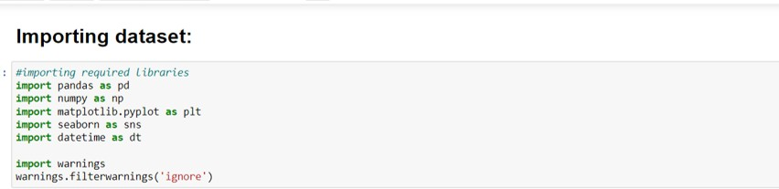

Then I separated the sheets present in our Excel spreadsheet and stored them in 2 different dataframe variables.



## Exploratory Data Analysis (EDA):

Exploratory Data Analysis, or EDA, is an important step in any Data Analysis or Data Science project. EDA is the process of investigating the dataset to discover patterns, and anomalies (outliers), and form hypotheses based on our understanding of the dataset.

After I got the dataset in our Jupyter Notebook I was able to notice that due to large number of rows and columns the information was truncated. Therefore, to overcome this challenge I used the pandas code as shown below.



I made sure to rename the column names that were ill formatted and quite long which made no sense to me. With the help of rename I was able to change the names of columns that were too lengthy and could have been accommodated in shorter formats.

Now was the time to take a look at any kind of missing values or null value that might have been present in our dataset.

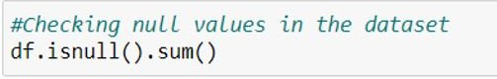

I went ahead to take a look into each record information by making use of describe, info and nunique methods.



I used a for loop to take a look at all the unique values present in the categorical columns covering the number of rows in the dataset.

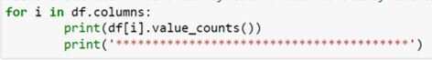

**Visualization:**



**What is Data Visualization?** Data visualization is defined as a graphical representation that contains the information and the data.

## Benefits of Good Data Visualization?

Data visualization is another technique of visual art that grabs our interest and keeps our main focus on the message captured with the help of eyes.

Different Types of Analysis for Data Visualization are:

1. Univariate Analysis: In the univariate analysis, we will be using a single feature to analyze almost all of its properties.
2. Bivariate Analysis: When we compare the data between exactly 2 features then it is known as bivariate analysis.
3. Multivariate Analysis: In the multivariate analysis, we will be comparing more than 2 variables.

## Univariate Analysis:

I used two for loops to generate a count chart for all columns, showing the percentage of data coverage and the observations after each chart as user input.

## Bivariate Analysis:

I performed bivariate analysis using count plots again and changing the hue format. Please refer the code and the outputs in GIF formats below:

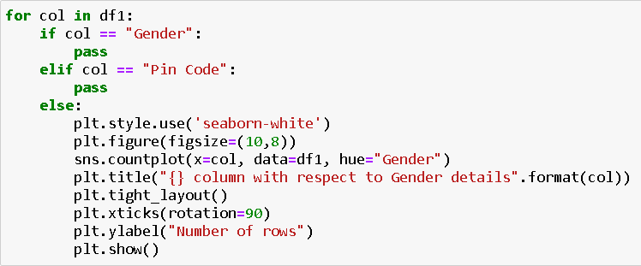Code:

Output:

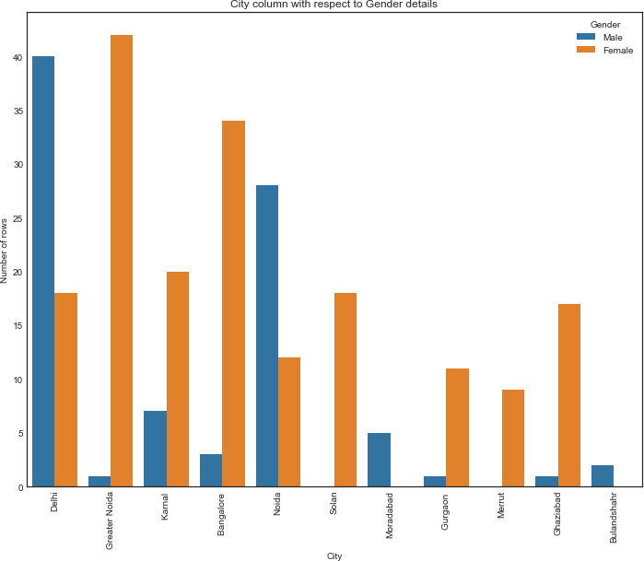

Code:

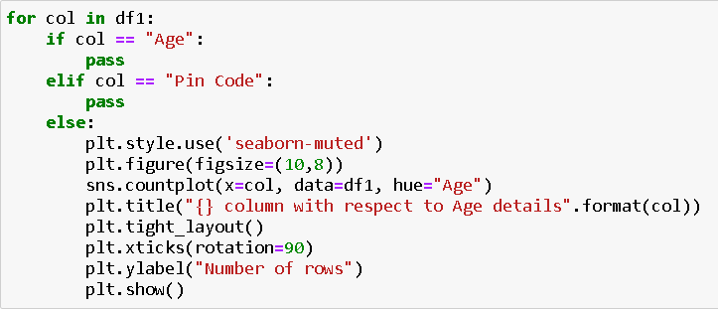

Output:

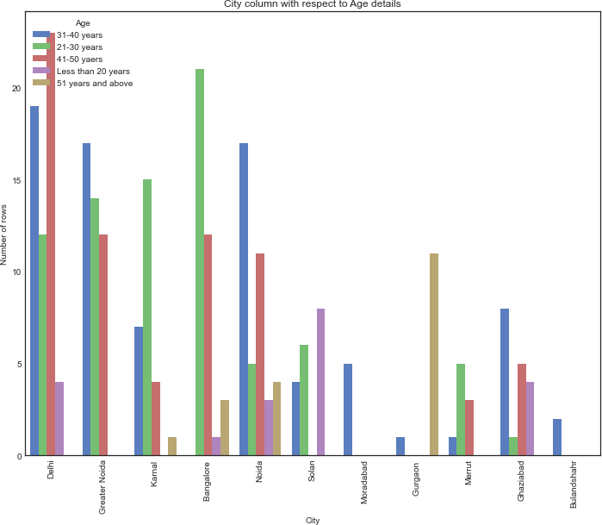

Code:

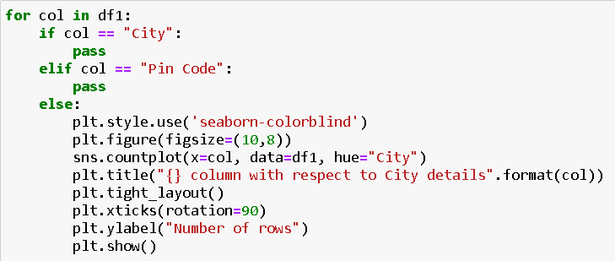

Output:

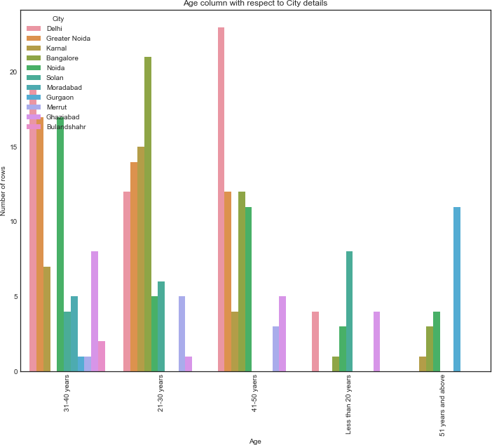

Next, I imported Coded data and checked and compared all the ratings column.

Code:

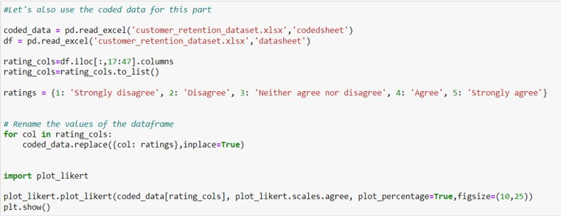

Output:

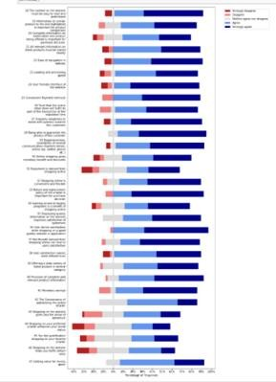

**Inference:**

# Amazon.com

*To be improved:*

* + During promotions, try to give a disturbance free shopping experience to customers.
  + Give more payment options to customers.
  + Try to give price early during promotion.
  + Reduce the delivery time of the products.

*Positive feedback summary:*

* + Convenient to use and also a good website for shopping.
  + Fast delivery of products.
  + Availability of complete information of the products.
  + Presence of online assistance through multi-channels.
  + Reliable website or app, perceived trustworthiness.

# Flipkart.com

*To be improved:*

* + During promotions, try to give a disturbance free shopping experience to customers.
  + Give more payment options to customers.
  + Try to give the price early during promotion.
  + Reduce the delivery time of the products.
  + Flipkart and Amazon almost share the same feedbacks with varying percentages as the only difference.

*Positive feedback summary:*

* + Convenient to use and also a good website for shopping.
  + Fast delivery of products.
  + Availability of complete information of the products.
  + Presence of online assistance through multi-channels.
  + Reliable website or app, perceived trustworthiness.
  + Wild variety of products to offer.

# Myntra.com

*To be improved:*

* During promotions, try to give a disturbance free shopping experience to customers.
* Try to give the price early during promotions.
* Reduce the delivery time of the products during promotions.

*Positive feedback summary:*

* Convenient to use and also a good website.
* Availability of several payment options.
* Faster products delivery.
* Complete information of products available.
* Reliable website or app, perceived trustworthiness.
* Wild variety of product to offer

# Paytm.com

*To be improved:*

* Reduce the delivery time of the products during promotions.
* Try to give the price early during promotion.
* During promotions, try to give a disturbance free shopping experience to customers.
* Late declaration of price and discounts.
* Frequent disturbance is occurring while moving from one page to another.

*Positive feedback summary*

* Convenient to use and a good website.
* Quickness to complete a purchase.
* About 64% of the customers feel that either web or app is reliable.
* Around 20% of the customers believe that Paytm has a wild variety of products on offer.

# Snapdeal.com

*To be improved:*

* Reduce the delivery time of the products during promotions.
* Try to give the price early during promotion.
* During promotions, try to give a disturbance free shopping experience to customers.
* Late declaration of price and discounts.
* No one has expressed to recommend Snapdeal to a contact as it has the most negative feedbacks among all other websites.

Positive feedback summary:

* Convenient to use.
* 54% of the customers are happy about the availability of financial information security.

# Conclusion:

The results of this study suggest following outputs which might be useful for E-commerce websites to extend their business

1. The cost of the product, the reliability of the E-commerce company and the return policies all play an equally important role in deciding the buying behaviour of online customers. The cost is an important factor as it was the basic criteria used by online retailers to attract customers. The reliability of the E- commerce company is also important, as it is even required in offline retail. It is important because customers are paying online, so they need to be sure of security of the online transaction. The return policies are important because in online retail customer does not get to feel the product. Thus, he wants to be sure that it will be possible to return the product if he does not like it in real. Whereas, the logistics factor, which included Cash on delivery option, One day delivery and the quality of packaging plays a secondary role in this process though these are Must-be-quality. This is so because these all does not interfere with the real product and people believe that this is the basic value that E-commerce websites provide.
2. All the websites were not equally preferred by online customers. Amazon was the most preferred followed by Flipkart. This can be explained easily by previous result that we got. These two companies are most trusted in the industry and hence, have a huge reliability. Also, the sellers listed on these websites are generally from Tier 1 cities as compared to Snapdeal and PayTM which have more sellers from tier 2 and 3 cities. Also, these websites have the most lenient return policies as compared to others and also the time required to process a return is low for these.

